**D2**

*In this report, I am going to show you how I created my program*

As this screenshot of the code shows that, it is over £20. Because the boss decided to put a limit on the HourlyRate and HoursWorked, this screenshots shows us what happens when you enter more than 40 hours and £20.

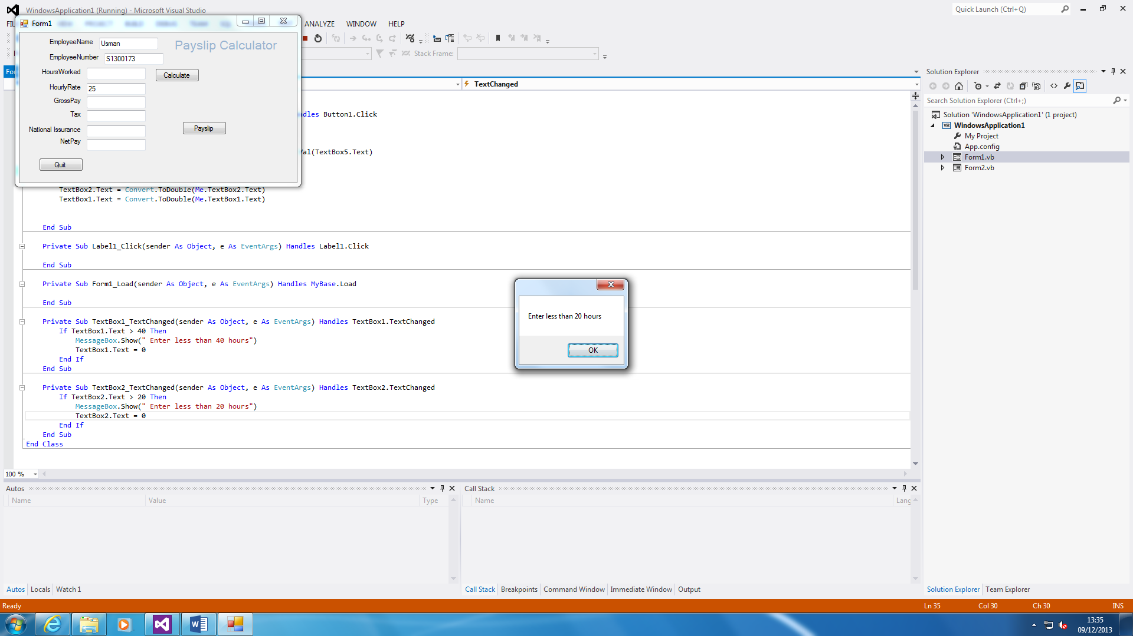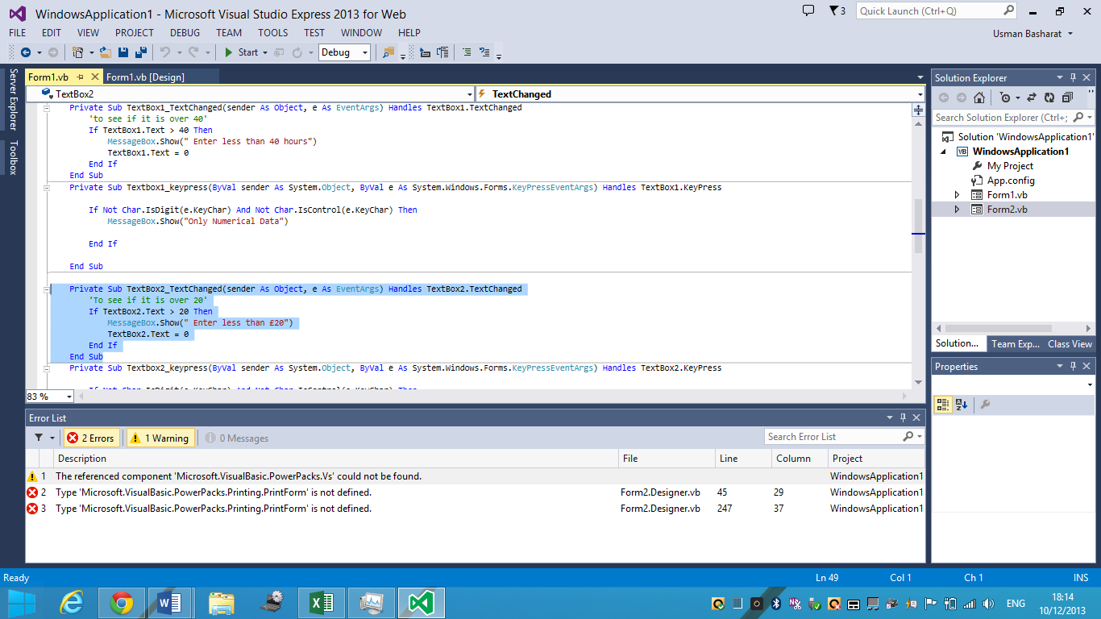

As these demonstrates that, the code works perfectly, because I entered 25, which straight away this message above popped up.

This is the same with the HoursWorked. I entered 45, which was unacceptable.

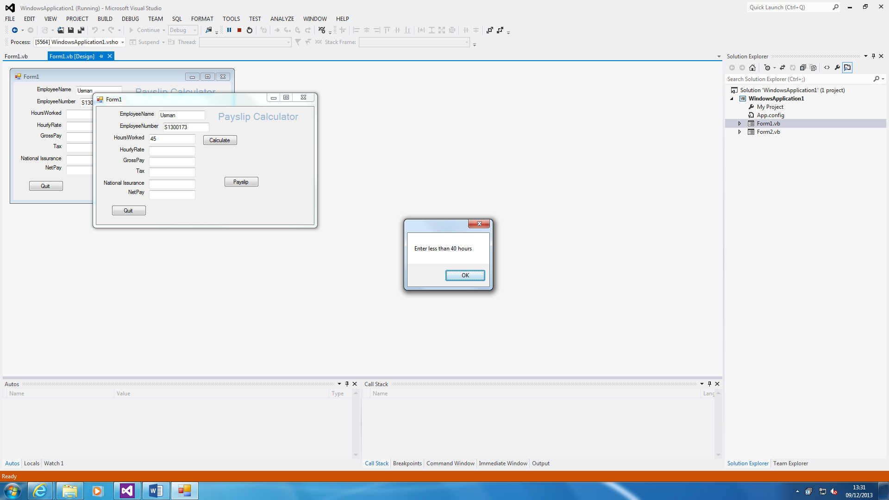

Public Class Form1

CODES

Private Sub Button1_Click(sender As Object, e As EventArgs) Handles Button1.Click

Try

'Calculate the Gross Pay'

TextBox3.Text = GrossPay()

'Calculate the tax'

TextBox4.Text = Tax()

'Calculate the National Insurance'

TextBox5.Text = NI()

'Calculate the NetPay'

TextBox6.Text = NetPay()

If TextBox1.Text = 0 Then

MessageBox.Show(" Numbers must be greater than 1, try again")

End If

If TextBox2.Text = 0 Then

MessageBox.Show(" Numbers must be greater than 1, try again")

End If

Catch ex As Exception

End Try

End Sub

Private Sub Label1_Click(sender As Object, e As EventArgs) Handles Label1.Click

End Sub

Private Sub Form1_Load(sender As Object, e As EventArgs) Handles MyBase.Load

End Sub

Private Sub TextBox1_TextChanged(sender As Object, e As EventArgs) Handles TextBox1.TextChanged

'to see if it is over 40'

If TextBox1.Text > 40 Then

MessageBox.Show(" Enter less than 40 hours")

TextBox1.Text = 0

End If

End Sub

Private Sub Textbox1_keypress(ByVal sender As System.Object, ByVal e As System.Windows.Forms.KeyPressEventArgs) Handles TextBox1.KeyPress

If Not Char.IsDigit(e.KeyChar) And Not Char.IsControl(e.KeyChar) Then

MessageBox.Show("Only Numerical Data")

End If

End Sub

Private Sub TextBox2_TextChanged(sender As Object, e As EventArgs) Handles TextBox2.TextChanged

'To see if it is over 20'

If TextBox2.Text > 20 Then

MessageBox.Show(" Enter less than £20")

TextBox2.Text = 0

End If

End Sub

Private Sub Textbox2_keypress(ByVal sender As System.Object, ByVal e As System.Windows.Forms.KeyPressEventArgs) Handles TextBox2.KeyPress

If Not Char.IsDigit(e.KeyChar) And Not Char.IsControl(e.KeyChar) Then

MessageBox.Show("Only Numerical Data")

End If

End Sub

Private Sub Button3_Click(sender As Object, e As EventArgs) Handles Button3.Click

'Open another form'

Form2.Show()

Form2.TextBox1.Text = Me.TextBox1.Text

Form2.TextBox2.Text = Me.TextBox2.Text

Form2.TextBox3.Text = Me.TextBox3.Text

Form2.TextBox4.Text = Me.TextBox4.Text

Form2.TextBox5.Text = Me.TextBox5.Text

Form2.TextBox6.Text = Me.TextBox6.Text

End Sub

Function GrossPay()

GrossPay = Val(TextBox2.Text) * Val(TextBox1.Text)

End Function

Function Tax()

Tax = Val(TextBox3.Text) * Val(0.2)

End Function

Function NI()

NI = Val(TextBox3.Text) * Val(0.1)

End Function

Function NetPay()

NetPay = Val(TextBox3.Text) - Val(TextBox4.Text) - Val(TextBox5.Text)

End Function

End Class

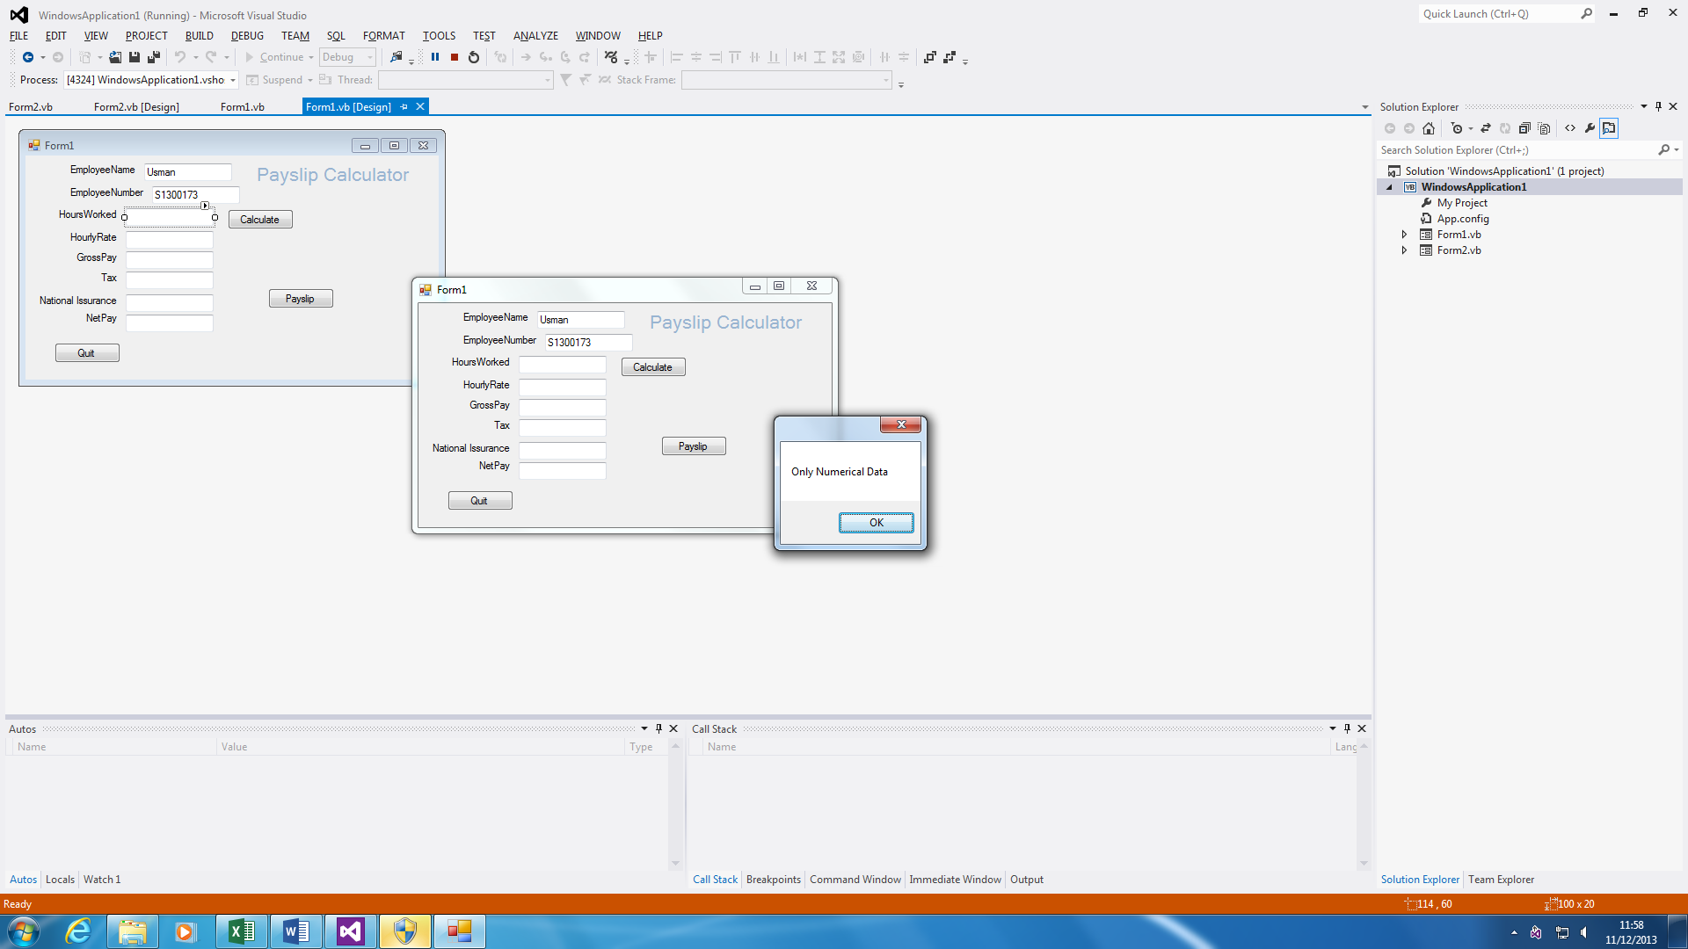

This is a ‘IF loop that I inserted in my program. Firstly I inserted it because only numerical data is allowed in the textbox. If a letter has been inserted, this error will appear.

In addition, this is similar to the second screenshot below. The numbers that are inserted must be greater than 1. Because if 0 is entered in HoursWorked and HourlyRate, nothing will be calculated.

The screenshots are there to prove that I’ve inserted it.

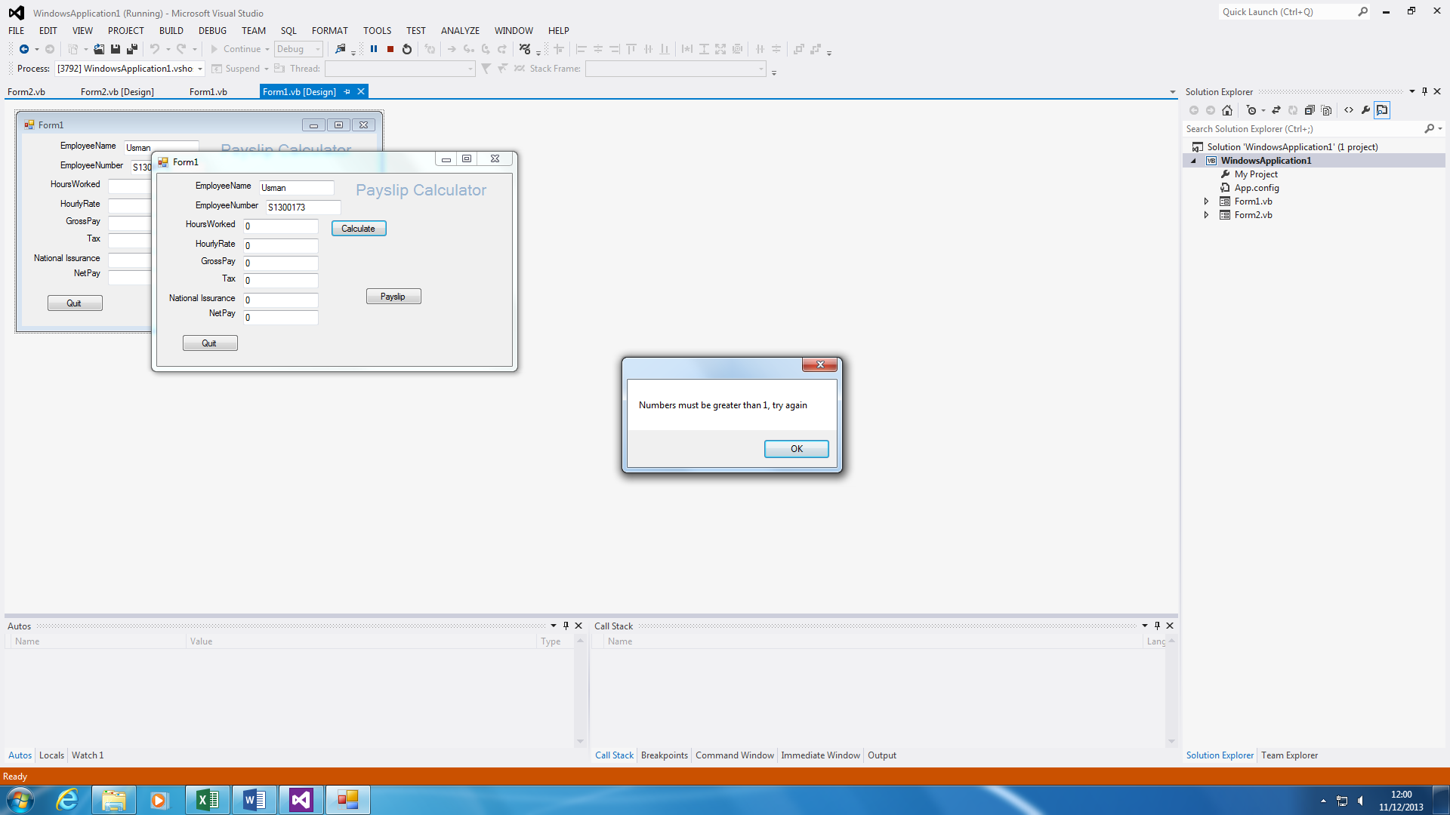

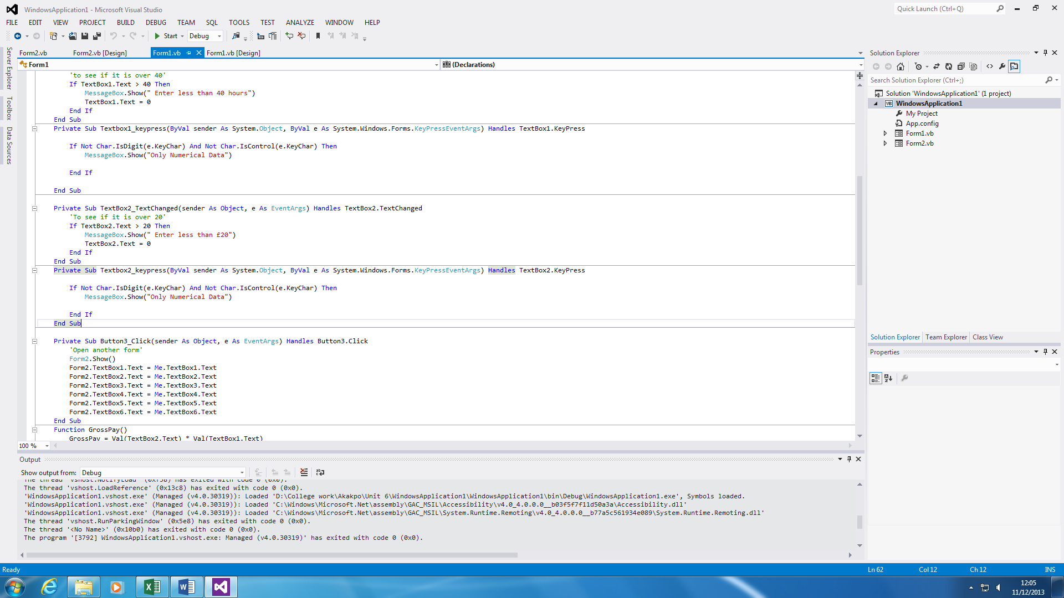

These screenshot is to show that I’ve entered an IF statement in my coding.

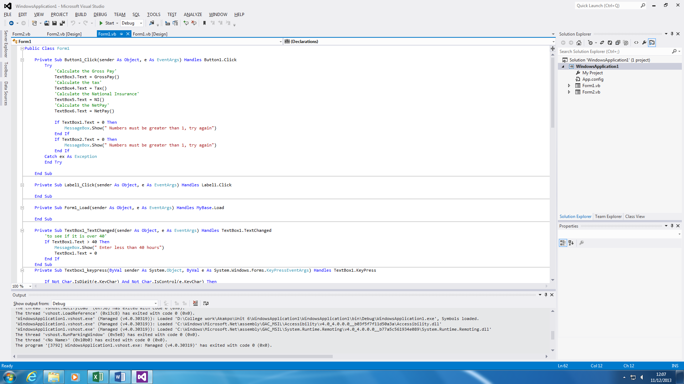

Test Plan

|  |  |  |  |  |
| --- | --- | --- | --- | --- |
| Test No | Test | Input | Expected Output | Actual Output |
| 1 | Enter a correct customer name | “Gary Smith” | Entry accepted | Entry accepted |
| 2 | Enter incorrect customer name | “67” | Error Message | Entry accepted |
| 3 | Input correct hours worked | “9” | Entry accepted | Entry accepted |
| 4 | Input incorrect hours worked | “Y” | Error Message | Entry declined |
| 5 | Input correct hourly rate | “6.99” | Entry accepted | Entry accepted |
|  |  |  |  |  |